**Efficiency of Upwind and Downwind Thai Sail Windmill**

*Teerawat Klabklay and Tawit Chitsomboon*

School of Mechanical Engineering, Suranaree University of Technology,

111, University Avenue, Muang Disdrict, Nakhon Ratchasima, 30000, Thailand.

**Abstract:** Conventional Thai sail windmill is a horizontal axis wind turbine for which a rotor is mounted in upstream position, upwind type, and there is no yaw control system. A yaw control system is mostly preferred for all horizontal axis wind turbines because it can help rotor face perpendicularly to all wind directions in order to avoid wind energy loss so that it can produce more annual energy production. Both small and medium scale of the upwind type normally can have a passive yaw control system by using a tail fin, while the downwind type is able to work as a passive yaw mechanism by itself. Although an efficiency of the downwind rotor is slightly less than of the upwind rotor, the downwind rotor does not need to equip any tail fin for working as a yaw control system. Therefore, if an efficiency of upwind and downwind rotor is likely to be similar, the downwind rotor should be better choice. The purpose of this study is to examine and compare an efficiency of upwind and downwind Thai sail windmill. For the experiment, 1.0 meter in diameter model was built and tested by tow testing method. Results showed that the maximum efficiency of upwind and downwind Thai sail windmill model was about 27% and 25%, respectively. Although the downwind model gave the maximum efficiency slightly less than the upwind model, it gave much more advantages such as being a passive yaw control system, which can make more annual energy production and use only one pole which can help reduce a construction cost.

**Key words:** *Thai sail windmill, Passive yaw control system, Upwind and downwind rotor, Wind turbine efficiency*

**INTRODUCTION**

Upwind and downwind are kinds of a horizontal axis wind turbine. Both types have different rotor positioning. Upwind type has a rotor in upstream, upwind type. The other has a rotor in downstream, downwind type [1]. A yaw control system was often preferred for all horizontal axis wind turbines because it can help a rotor perpendicularly face to all wind directions and avoid wind energy loss so that it can make more annual energy production. A yaw control system normally presents in two manners, namely active and passive yaw control system. The active yaw control system typically uses for large scale wind turbines only, while the passive yaw control system would only use for small or medium scale. A tail fin is a simple device which is able to be used as a passive yaw mechanism for the small scale of upwind wind turbine whereas the downwind rotor would be able to work as a passive yaw mechanism by itself [2, 3, 4]. Therefore, if an efficiency of upwind and downwind rotor is likely to be similar, the downwind rotor should be better choice because it does not need to equip any tail fin so a construction cost would be decreased. Some years ago a study by Mukhia [5] talked about Thai sail windmill used in a salt farm in Thailand especially in the Samut Sakhon and Samut Songkhram Province. It is used to pump brine water into a salt yard by using wind energy for salt production. Conventional Thai sail windmill is a horizontal axis wind turbine with the upwind type rotor and there is no yaw control system. The conventional Thai sail windmill typically absorbed wind only in two main directions either northeast (November-January) or southwest (May-October)[6] as a monsoon in Thailand. For the other period in year, the free stream of wind may be changed to another direction causing wind energy loss since such wind direction would be not perpendicular to the rotor plane. Therefore, Thai sail windmill should install whatever type of passive yaw control system to help the rotor face perpendicularly to all wind directions at all time for enhancing an annual energy production. This article is to investigate and compare an efficiency of upwind and downwind Thai sail windmill to assess what type of rotor is the best. A study by Thumthae [7] shows an influence of pitch angle affecting the power output for an untwisted blade wind turbine with using computational fluid dynamics (CFD). Results of this study show that the pitch angle is a variable which significantly affects an efficiency of wind turbines similar to Wei et al. [8] study.For the experiment, 1.0 meter in diameter model was constructed and tested with four pitch angles as follows: 5, 10, 15, and 20 degrees. For the testing method, actually there are typically three basic methods for the wind turbine testing, namely by wind tunnel, by tow testing, and by field testing [1]. Because the suitable wind tunnel cannot be provided and there are some limits of measuring device, this study chose deliberately the tow testing method, which is similar to various experiments such as by Maughmer [9].

**EXPERIMENT**

**Modeling**

A full scale of Conventional Thai sail windmill commonly 8.0 meters in diameter as shown in figure 1 is too large to install on a vehicle (pick-up truck) in order to test by tow testing method. Thus, all models would be scaled down to 1.0 meter in diameter to be more practical. Tested models were composed of upwind and downwind Thai sail windmill models as shown in figure 2 and figure 3 respectively. Both models presented 6 blades made of canvas which were tailored in a triangular shape with the same solidity of 28%. Solidity is a ratio between the projection area of all blades and the swept area. Besides pitch angles of all blades would be set by four angles as follows: 5, 10, 15 and 20 degrees at the tip. Actually, the pitch angles of Thai sail windmill blade are not constant along the span radius because it is not a rigid body so it would cause an automatic twisting behavior. Therefore, the pitch angles referred to in this study means the pitch angle specifically at the tip blade () as shown in figure 4. Additionally, it should be noted that this pitch angle was just a superficial angle, not real, because the true pitch angles would be different when a rotor was rotating.

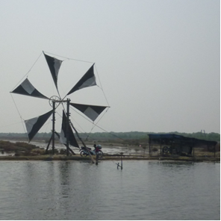

Fig 1 Conventional Thai sail windmill

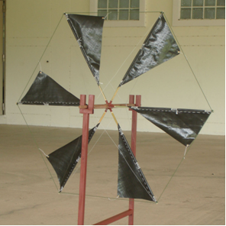

Fig 2 Upwind Thai sail windmill model

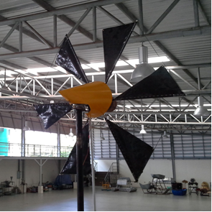

Fig 3 Downwind Thai sail windmill model

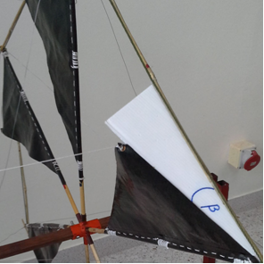

Fig 4 Pitch angle

Testing

For the tow testing preparation, a carbon steel rack was installed on the vehicle for fastening the models, including accessories such as spring balances, a speed sensor, and an anemometer, as shown in figure 5 and figure 6 for the upwind and downwind model installation, respectively. The rotor was placed 2.5 meters away from the top of the vehicle’s roof. This height is high enough to avoid air flow disturbance. The testing procedure is explained briefly below.

1) Install the carbon steel rack, model, and all accessories on the vehicle.

2) Monitor the local wind, the vehicle starts moving only if the local wind does not exceed 5% of the tested speed.

3) Move the vehicle by a constant speed on the route which must be straight and not sloping. It should be noted that the speed of the vehicle is the same as the free stream velocity for testing in a wind tunnel.

4) Turn the turnbuckle, to break the shaft rotor, for regulating the rotor speed.

5) Record F1, F2, and the rotor speed (N) only if the testing starts going to a steady state.

6) Regulate the rotor speed for a lower speed by turning the turn buckle for more friction and record data as in the previous step until the rotor finally stops rotating.

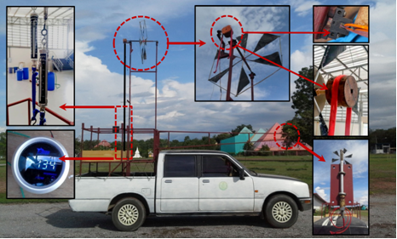

Fig 5 Equipment installation for the upwind model

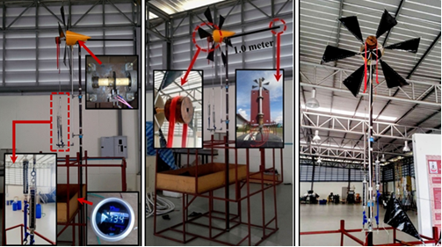

Fig 6 Equipment installation for the downwind model

**CALCULATION**

Three variables needed to measure for finding a power coefficient or an efficiency of the wind turbines consist of wind velocity, rotor speed, and shaft torque. Figure 7 shows free body diagram of a shaft torque at a pulley reacting to the belts and springs. According to Newton’s first law of motion, in the steady state, the relative torque must be zero, so the shaft torque can be determined



where  is the shaft torque, F1 and F2 are forces displayed on the springs F1 and F2, respectively, and  is radius of the pulley. Then, the shaft torque determines the power coefficient as follows [10, 11]



where  is a power coefficient,  is the density of air , A is a rotor swept area, u is a velocity of moving vehicle, which is the same as a wind velocity, and  is an angular velocity of rotor given by

,

where N is a rotor speed (rpm) which is measured by the speed sensor. By the way, the power coefficient is typically plotted with the tip-speed ratio which is calculated by



where  is a tip-speed ratio and R is a radius of the rotor.For the wind turbine efficiency, it can be known basically by conducting the power coefficient times 100% as below



where  is a wind turbine efficiency.

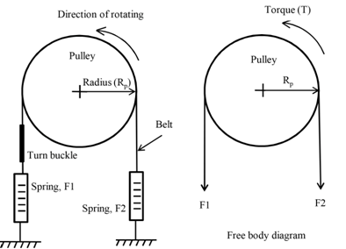

Figure 7 Free body diagram

**RESULT AND DISCUSSION**

First results, the downwind Thai sail windmill model (DTSW) was tested within three wind velocities, namely 4.2, 5.6, and 7.0 m/s, which resemble to weather in Thailand, in order to examine the wind velocity effect to power coefficient or efficiency. Furthermore, all models were tested by four pitch angle as follows: 5, 10, 15, and 20 degrees so that it can also be found out an optimum point of pitch angle of the sail blade. Figures 8-11 show the results of power coefficient variations of the downwind Thai sail windmill model along the tip-speed ratio. It was observed that the model tested with higher wind velocity gave slightly more power coefficient, except on the case of the pitch angle of 20 degree, because the aerodynamic loads of the blade profile, lift to drag ratio, were improved by Reynolds numbers. A similar result was reported by Monteiro et al. [12] and Kishore and Priya [13]. For another result, it was apparent that the pitch angle of 10 degrees presented maximum power coefficient of 0.27, or the efficiency of 27%, because this pitch angle was an optimum point creating the greatest blade profile of the Thai sail windmill causing to get an optimum angle of attack and produces maximum lift to drag ratio and the shaft torque. It should be noted that the tip-speed ratio is an inverse relation of the angle of attack [10, 11]. Besides, it can be seen that the left side of the curve in figures 8-11, after the peak point, which was the state for very low rotor speed, the power coefficient data was not shown because this state the model was operating with very high angle of attack (too slow speed) until the stall phenomenon was occurred since the angle of attack was too high ([14], [15], [16]).

For the main results, figures 12-15 show power coefficients contrast between upwind and downwind Thai sail windmill model. It is very clear that the maximum power coefficient of downwind model was slightly less than the upwind rotor. The upwind and downwind model gave the maximum power coefficient of 0.27 and 0.25, or efficiency of 27% and 25%, respectively. The optimum pitch angle of both models was the same, which was about 10 degrees. The downwind model presents some obstruction devices in front of the rotor such as the pole, bearing set, which caused the wind energy loss and wake, this is the reason why the downwind Thai sail windmill model gave efficiency slightly less than the upwind Thai sail windmill model. However, downwind type rotor should be better choice for Thai sail windmill rather than the upwind rotor because although the downwind model gave efficiency less than the upwind model, it was merely small difference and it gave much more advantages, for example, it can be a passive yaw mechanism by itself for helping the rotor face perpendicularly to all wind directions and use only onepole, which can reduce the construction cost, while the conventional Thai sail windmill (Upwind type) use two poles and must equip the tail fin for a yaw control system.

Additionally, power coefficient of the upwind Thai sail windmill model by without the yaw control system would not practically reach 0.27, or efficiency of 27%, because a free stream of wind can change direction at all time which is the cause of wind energy loss.

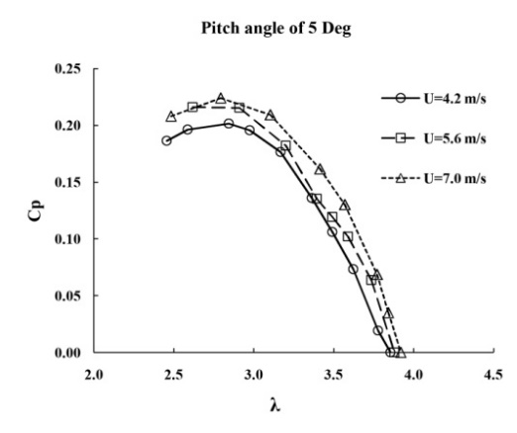

Figure 8 Power coefficients of DTSW with 

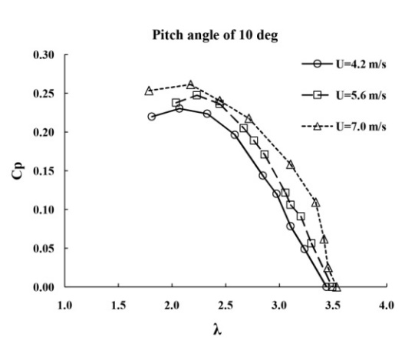

Figure 9 Power coefficients of DTSW with 

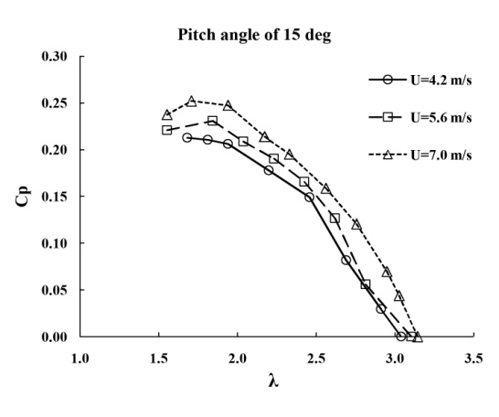

Figure 10 Power coefficients of DTSW with 

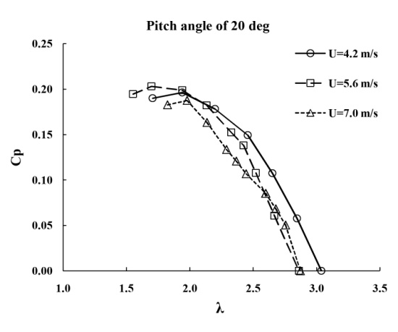

Figure 11 Power coefficients of DTSW with 

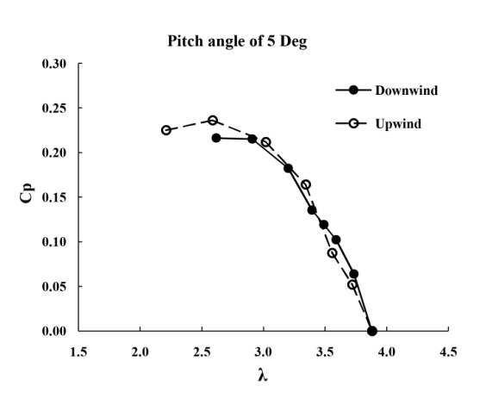

Figure 12 Power coefficients with 

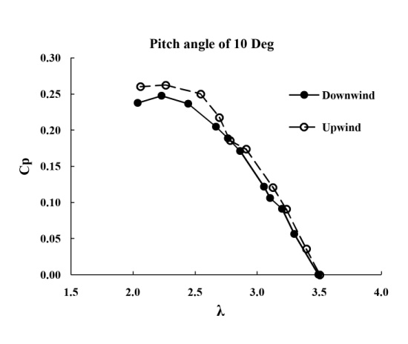

Figure 13 Power coefficients with 

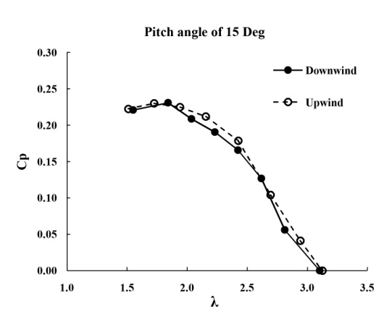

Figure 14 Power coefficients with 

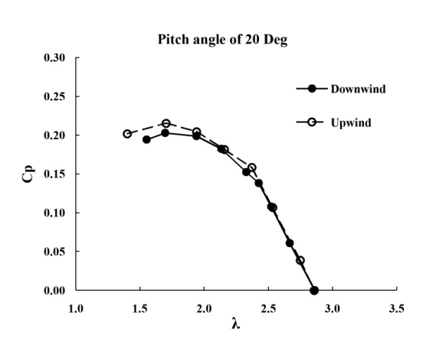

Figure 15 Power coefficients with 

**CONCLUSION**

Maximum efficiency of upwind and downwind Thai sail windmill model was, respectively, about 27% and 25% which was slightly different. Optimum pitch angle of both models was the same at 10 degrees. However, the downwind rotor was better choice for Thai sail windmill rather than the upwind rotor because although the downwind model gave efficiency less than the upwind model, it was merely small difference and it gave much more advantages, for example, it can be a passive yaw mechanism by itself for helping a rotor face perpendicularly to all wind directions and use only onepole, which can reduce a construction cost and enhance an annual energy production.

**ACKNOWLEDGMENTS**

The authors acknowledge the financial support from Suranaree University of Technology (SUT), Nakhon Ratchasima, Thailand.

**REFERENCES**

[1] Spera, A.D. 1998. Wind turbine technology: fundamental concepts of wind turbine engineering. ASME press.

[2] Gipe, P. 2004. Wind power. James & James (Science Publishers).

[3] Wenzhuan, C., Xiongwei, L., Feng, Y. and Whitty, J. 2009. Analysis of the Passive Yaw Mechanism of Small Horizontal-Axis Wind Turbines. IEEE

[4] Kress, C., Chokani, N. and Abhari, R.S. 2015. Downwind wind turbine yaw stability and performance. Renewable Energy 83, 1157-1165.

[5] Mukhia, P. 1981. Performance and aerodynamic analysis of the Thai four bladed wooden rotor coupled to a ladder pump. M.Eng. thesis, AIT.

[6] Exell, R.H.B. 1981. Surface wind distributions in Thailand. Journal of the Science Society of Thailand, 7, 154-169.

[7] Thumthae. Ch. and Chitsomboon, T. 2009. Optimal angle of attack for untwisted blade wind turbine. Renewable Energy 34, 1279-1284.

[8] Wei, X., Pan, Z. and Liping, L. 2015. Wind tunnel experiments for innovative pitch regulated blade of horizontal axis wind turbine. Energy 91, 1070-1080.

[9] Maughmer, M.D. 1976. Optimization and Characteristics of Sailwing Windmill Rotor. Final report/ AMS report no. 1297. Princeton University.

[10] Burton, T., Jenkins, N., Sharpe, D. and Bossanyi, E. 2011. Wind energy handbook, 2nd edn, John Wiley & Sons Ltd, West Sussex.

[11] Manwell, J.F., Mcgowan, J.G. and Rogers, A.L. 2009. Wind energy explained, 2nd edn, John Wiley & Sons Ltd, West Sussex.

[12] Monteiro, J., Silvestre, M.R., Piggot, H. and Andre, J.C. 2013. Wind tunnel testing of a horizontal axis wind turbine rotor and comparison with simulations from two Blade Element Momentum codes. Journal of wind engineering and industrial aerodynamics 123, 99-106.

[13] Kishore, R.A. and Priya, S. 2013. Design and experimental verification of a high efficiency small wind energy portable turbine (SWEPT). Journal of wind engineering and industrial aerodynamics 118, 12-19.

[14] Choudhry, A., Arjomandi, M. and Kelso, R. 2016. Methods to control dynamic stall for wind turbine applications. Renewable Energy 86, 26-37.

[15] Qing’an, L., Yasunari, K., Takao, M., Junsuke, M. and Yusuke, N. 2016. Visualization of the flow field and aerodynamic force on a Horizontal Axis Wind Turbine in turbulent inflows. Energy 111, 57-67.

[16] Meng-Hsien, L., Shiah, Y.C. and Chi-Jeng, B. 2016. Experiments and numerical simulations of the rotor-blade performance for a small-scale horizontal axis wind turbine. J Wind Eng Ind Aerodyn 149, 17-29.